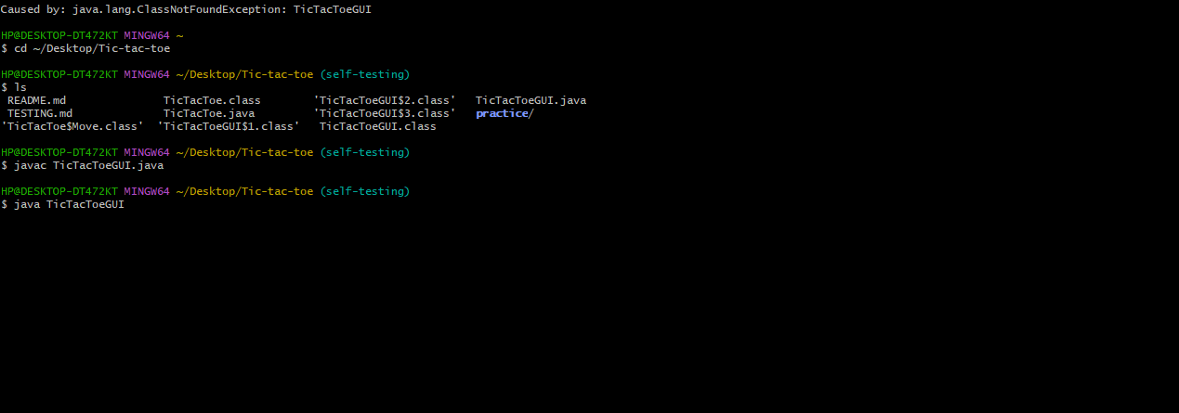
The screenshot shows the launch and compile command. We have compiled the code and run it using the following command:
javac TicTacToeGUI.java java TicTacToeGUI

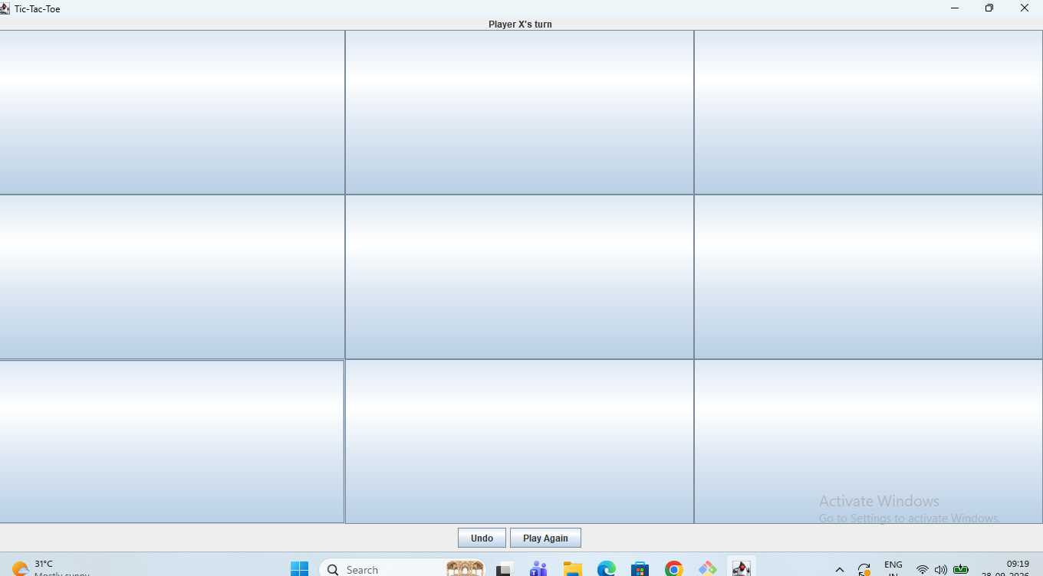

We have compiled the program. Now an entry board is popped-up and the turn label is shown as: Player X’s turn. The other label is shown as: Undo and Play Again.

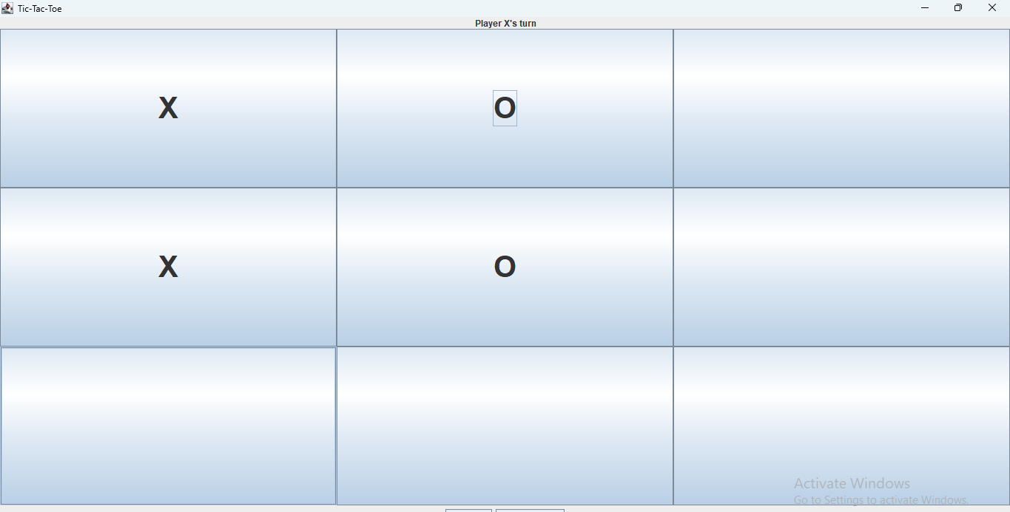
A few moves in: X and O on the board, and the label showing whose turn it is: Player X’s turn. The board automatically displays Player O’s turn after each turn of Player X.

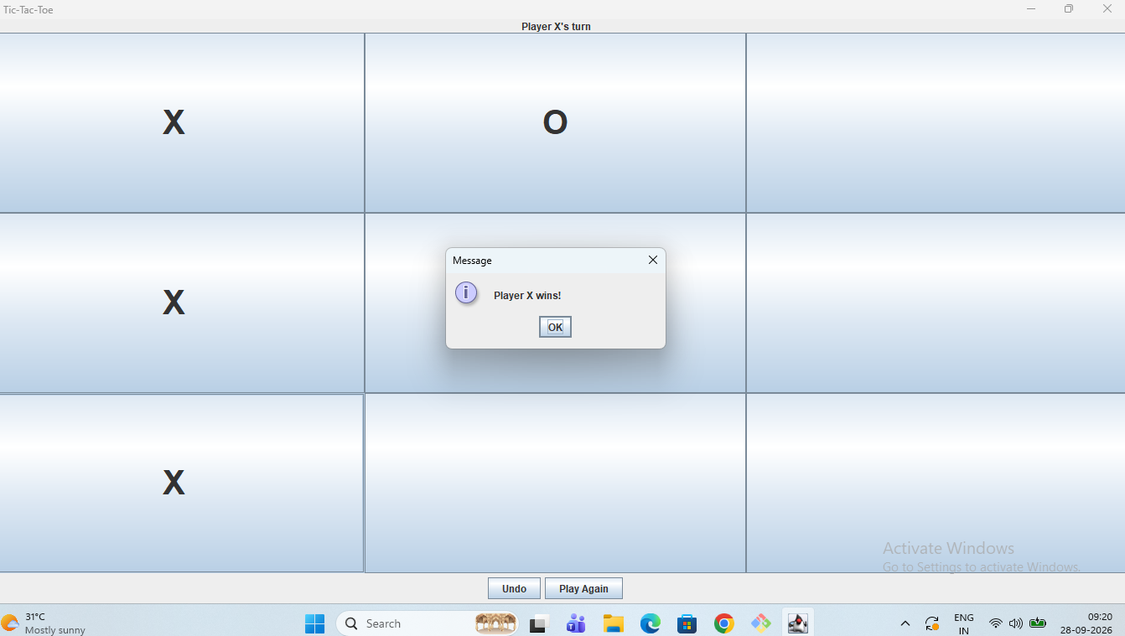

A win: the board and the win message. Player X’s win

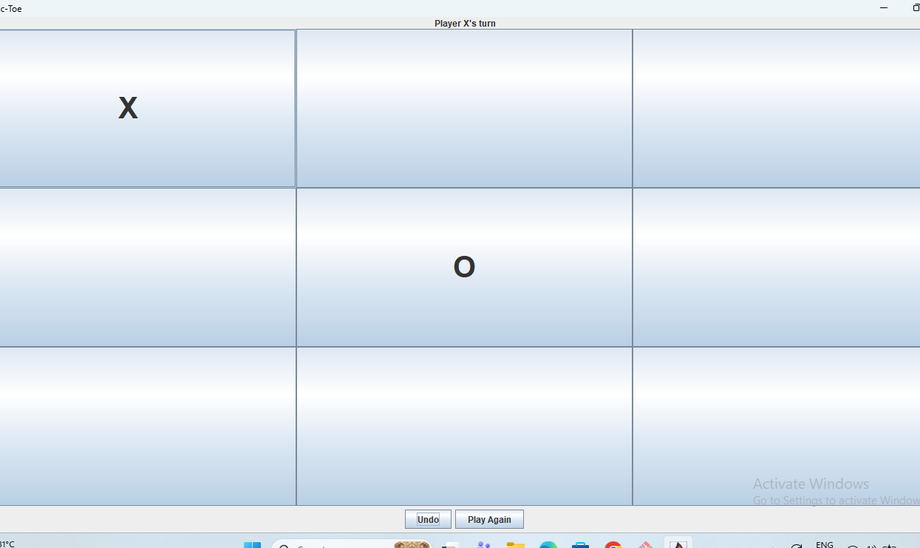

It is the scene before undo: 1 X and 1 O

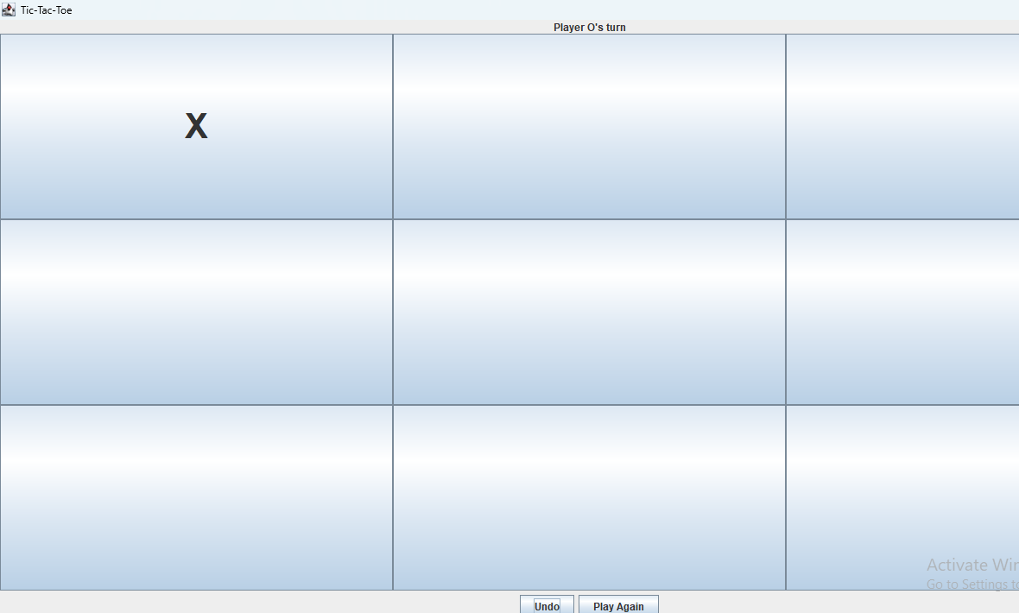
It is the scene after pressing the undo button: Player O’s turn. The display board shows: 1 X

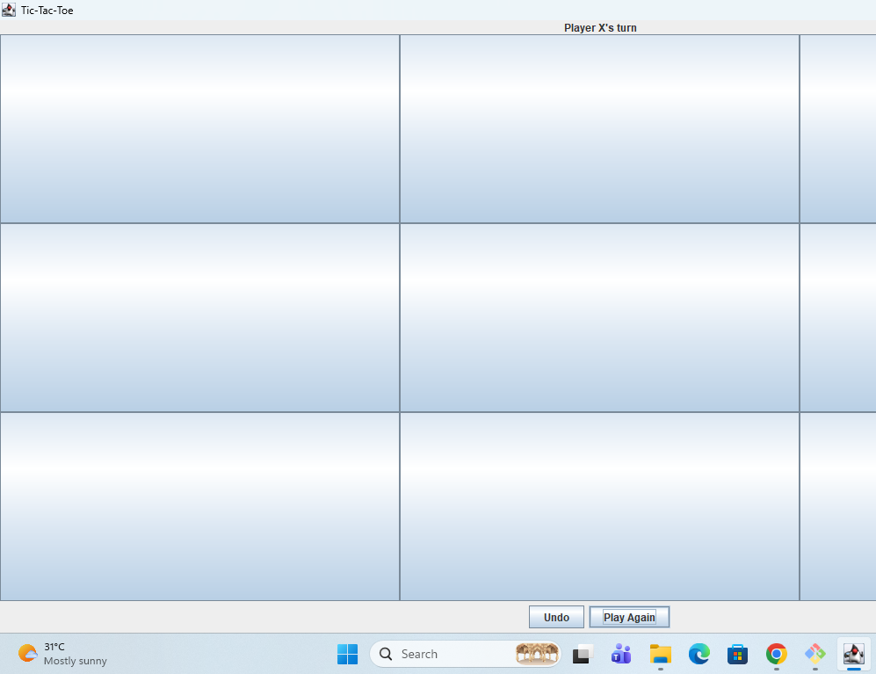

After pressing the Play again button, it shows the empty board where we can play again

